Chapter 2, Solution 70

(a) Using voltage division,
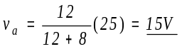
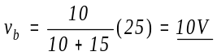
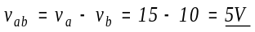

(b) c

+ 8k 15k
25 V
– a b

12k 10k

v_{a} = 0; v_{ac} = –(8/(8+12))25 = –10V; v_{cb} = (15/(15+10))25 = 15V.

v_{ab} = v_{ac} + v_{cb} = –10 + 15 = 5V.

v_{b} = –v_{ab} = –5V.

